**ILP -1 CI-CD Bookstore**

Project deliverables are available at : <https://topgear-training-gitlab.wipro.com/AI391167/ILP_BookStoreWorkspace.git>

**Snapshots**

**Jenkins snapshots:**

**Jenkins global config:**

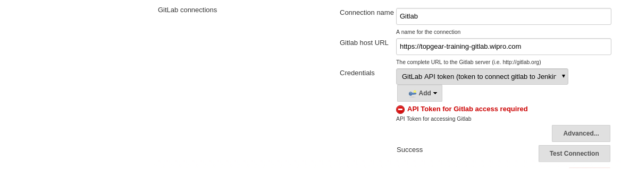global git lab configuration

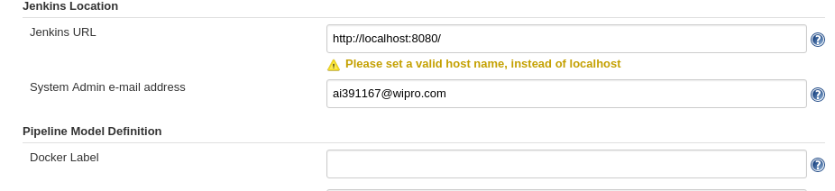global jenkins configuration

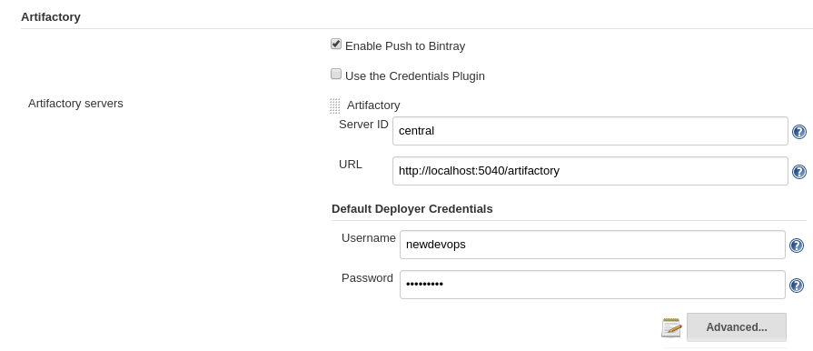global repository config

**Jenkins job config**

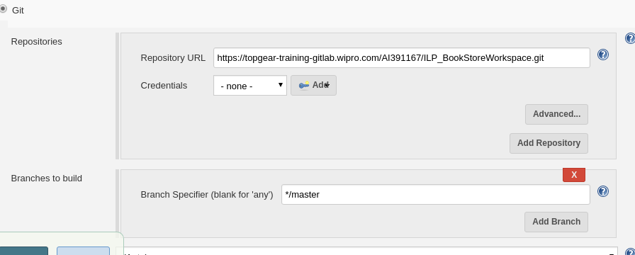git config

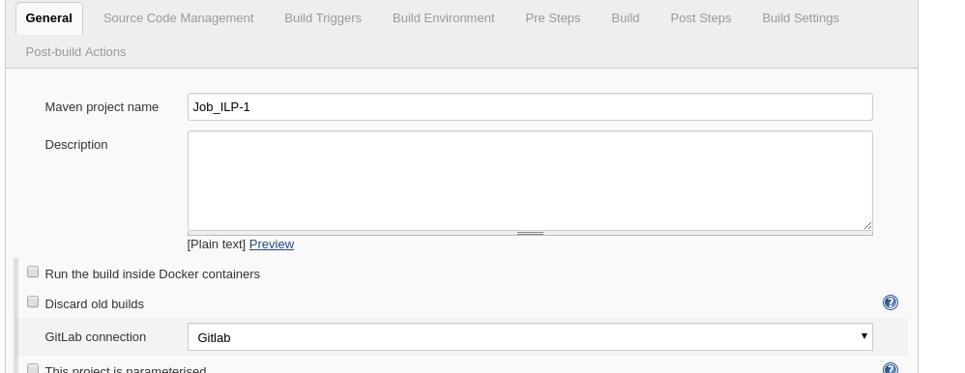project name

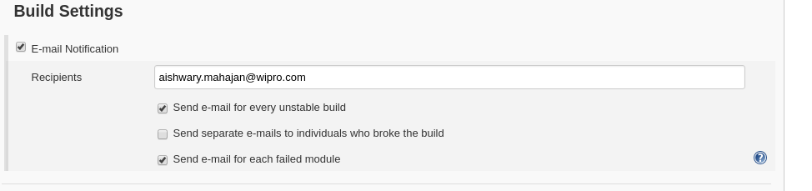Build failure notification

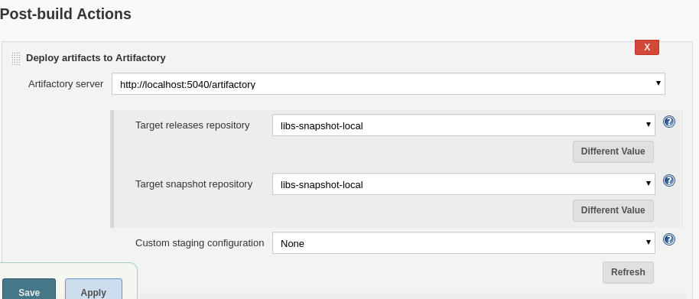

artifactory config

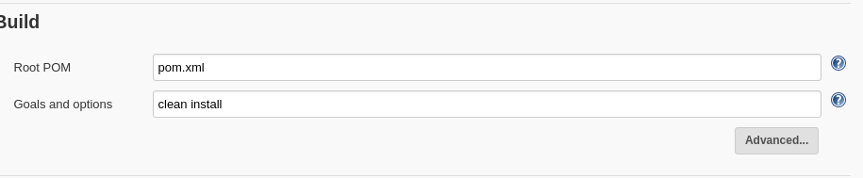

Build config

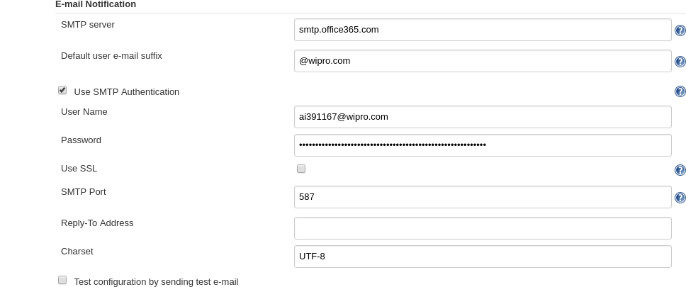

email config

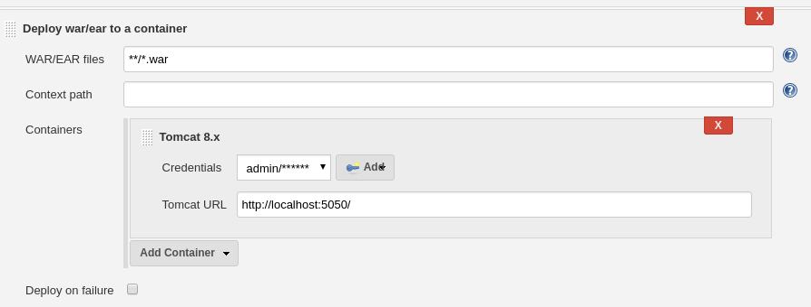Tomcat config

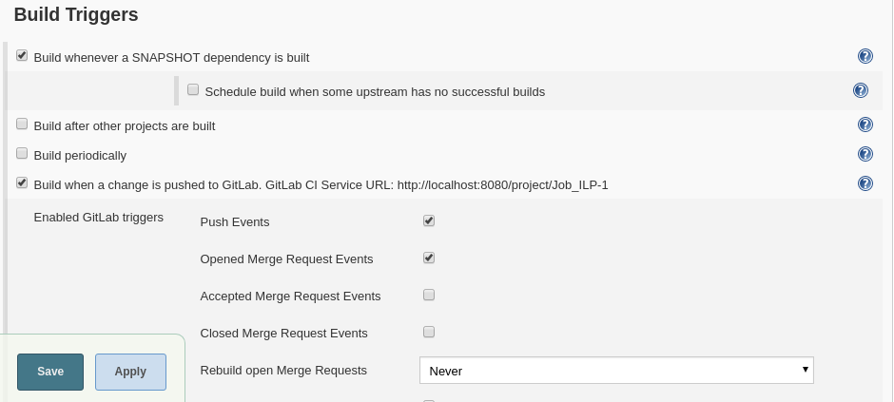

Webhook build trigger config

**Webserver snip**

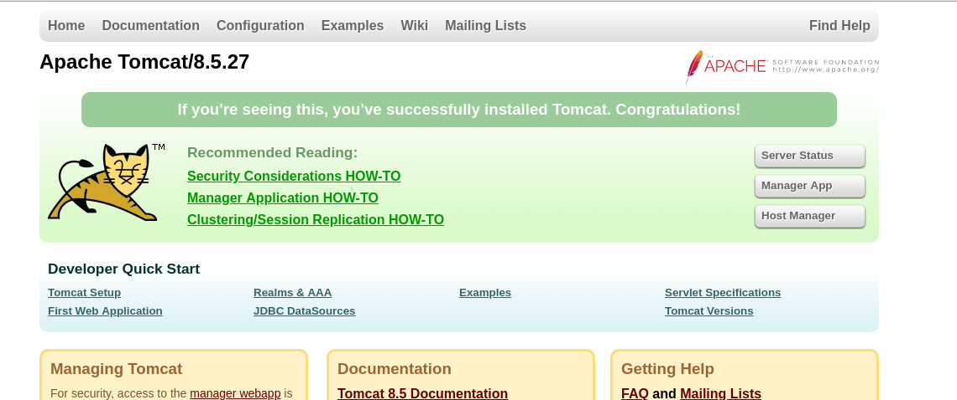

**Web application UI snip**

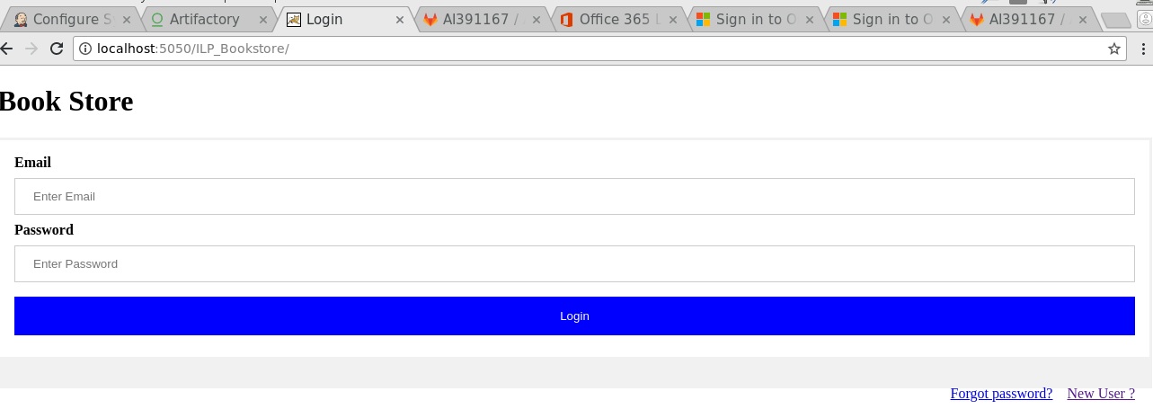

Application home page

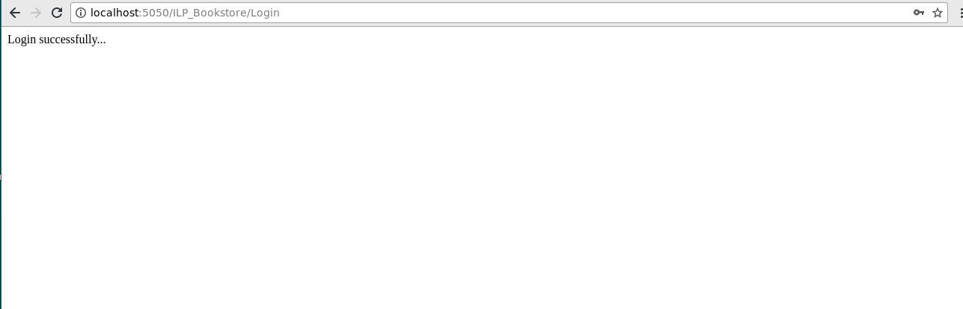

Application successful login

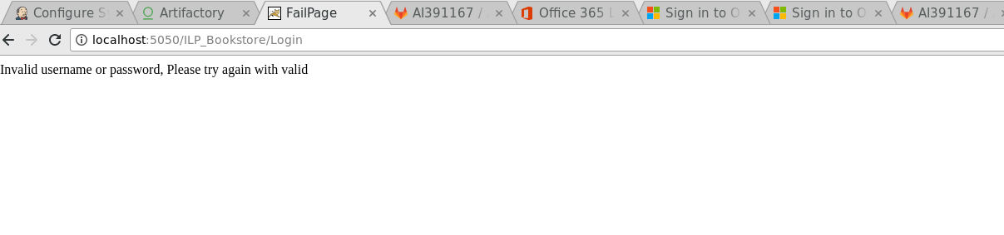

Application unsuccessful login